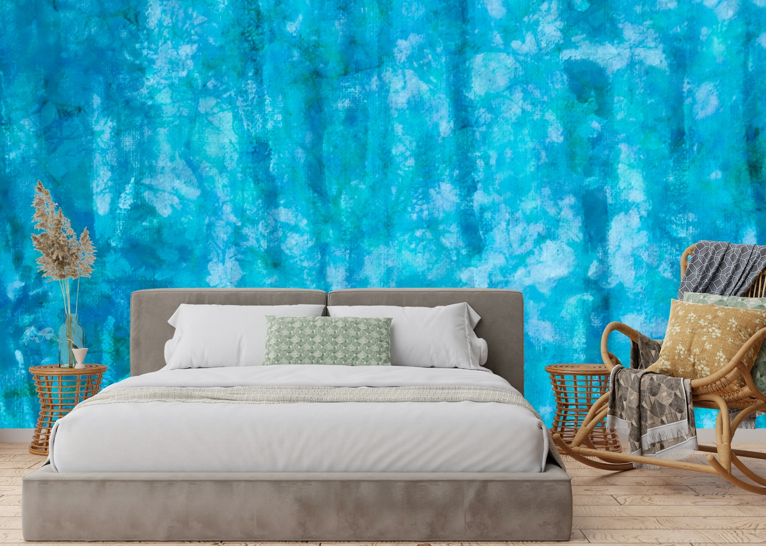

Flowers in the Forest Mural is a fusion of images to bring a world of imagination where everything is possible while admiring art of nature with reverence.

“Forests were the first temples of the divinity, and it is in the forests that men have grasped the first idea of architecture.”- Francois-Rene de Chateaubriand

This unique collection is now available and custom printed on non-woven mat stucco effect wallpaper suitable for residential and commercial projects. For further information, I invite you to contact my representatives in New York and Amsterdam.

New York Representative: Christopher Kohler +1 917 719 1836
Europe Representative: 📧 Vivianne Laude
info@marleneluce.com
Made with love in Montreal, Canada.

