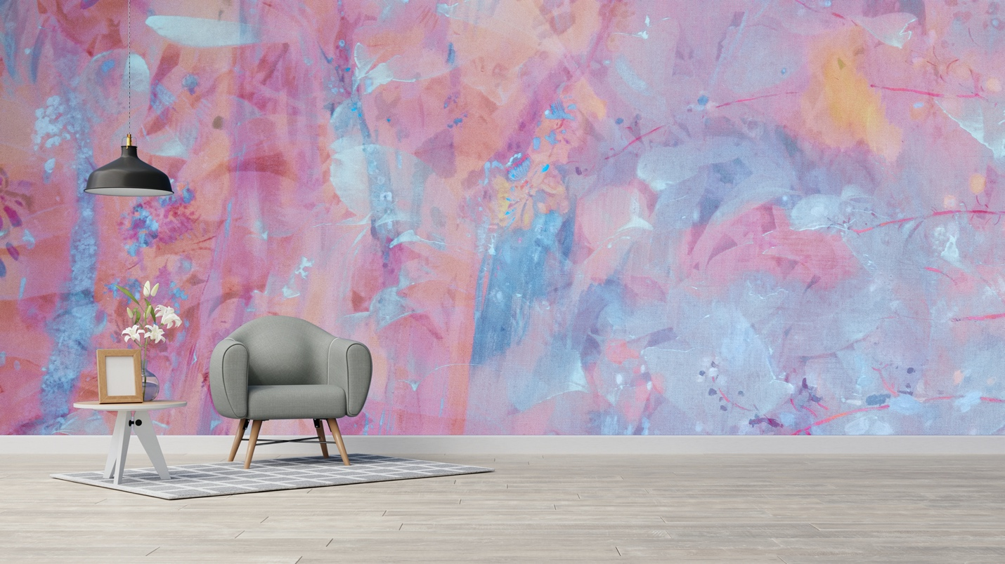

Luminous Blues Mural brings art and an appreciation of beauty, a world of color and light.

“The artist’s vocation is to send light into the human heart.” – George Sand

Canadian artist Marlene Luce’s inspiration comes from a mixture of images from the natural world while traveling.
This collection is custom printed on non-woven mat stucco effect wallpaper suitable for residential and commercial projects.
Marlene Luce is represented by Christopher Kohler m: +1-917-719-1836
at info@marleneluce.com
Made with love in Montreal, Canada.
https://wynil.com/collections/marlene-luce-artist

