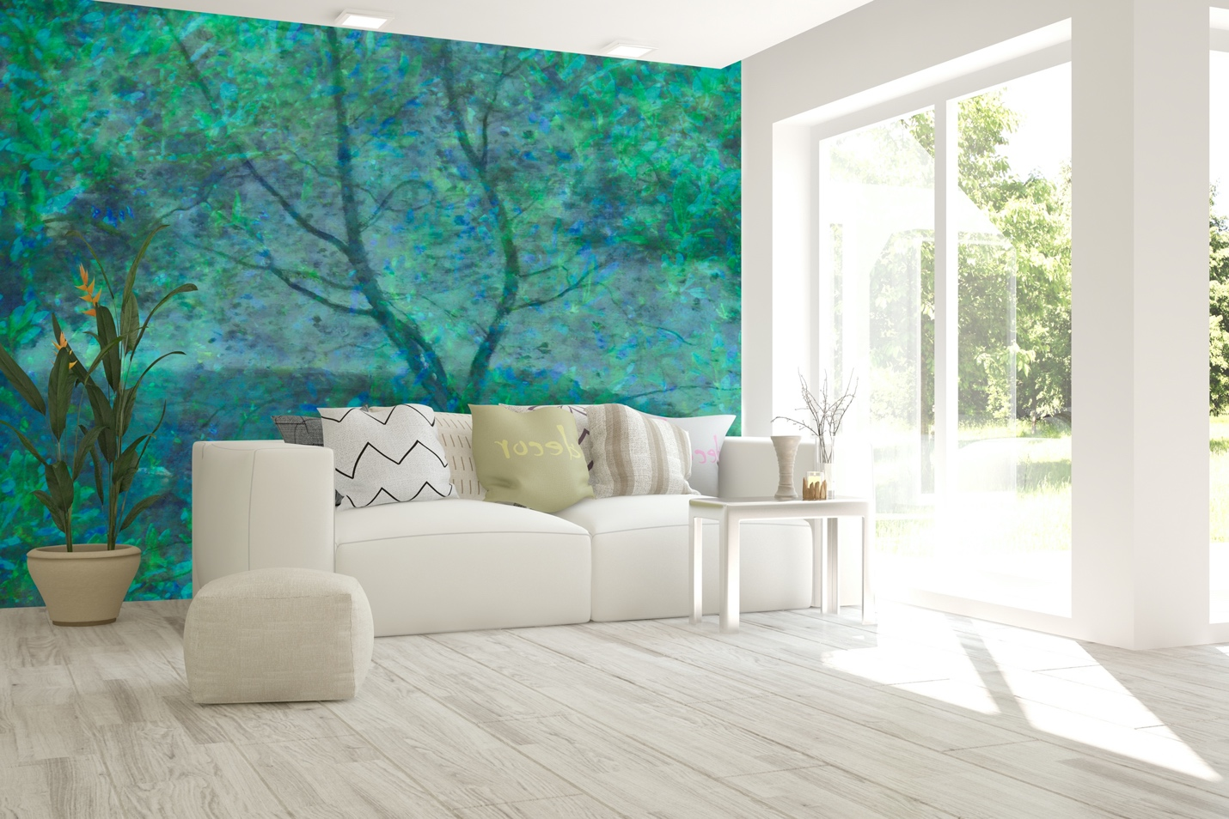

Green Meadow Mural evokes feelings of renewal, balance, and calm. It's considered to be restful for the eyes and can even help relieve stress. Green is suitable for nearly any room in your home where you want to create an atmosphere of warmth, comfort, and relaxation.

“Trees are the earth’s endless effort to speak to the listening heaven.” – Rabindranath Tagore

Canadian artist Marlene Luce’s inspiration comes from a mixture of images from the natural world while traveling.
This collection is custom printed on non-woven mat stucco effect wallpaper suitable for residential and commercial projects.
Marlene Luce is represented by Christopher Kohler m: +1-917-719-1836
at info@marleneluce.com
Made with love in Montreal, Canada.
https://wynil.com/collections/marlene-luce-artist

