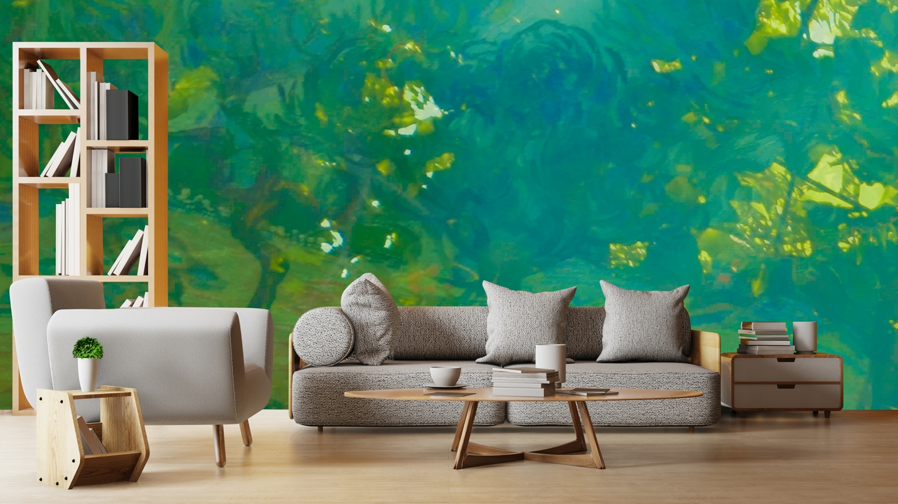

Veil of Fantasy Mural brings a world of fantasy featuring nature in art and colour beyond reality and conducive to joy in appreciation of the natural world while being part of something larger than ourselves.

“Heaven and earth, the Celtic saying goes, are only three feet apart, but in thin places that distance is even shorter. They are places that make us feel something larger than ourselves, as though we are held in a place between worlds, beyond experience.” - Kerri Ní Dochartaigh, Thin Places (Kerri ní Dochartaigh is a Northern Irish writer known for her nature writings.)

This unique collection is now available and custom printed on non-woven mat stucco effect wallpaper suitable for residential and commercial projects. For further information, I invite you to contact my representatives in New York and Amsterdam.

New York Representative: Christopher Kohler +1 917 719 1836
Europe Representative: 📧 Vivianne Laude
info@marleneluce.com
Made with love in Montreal, Canada.

