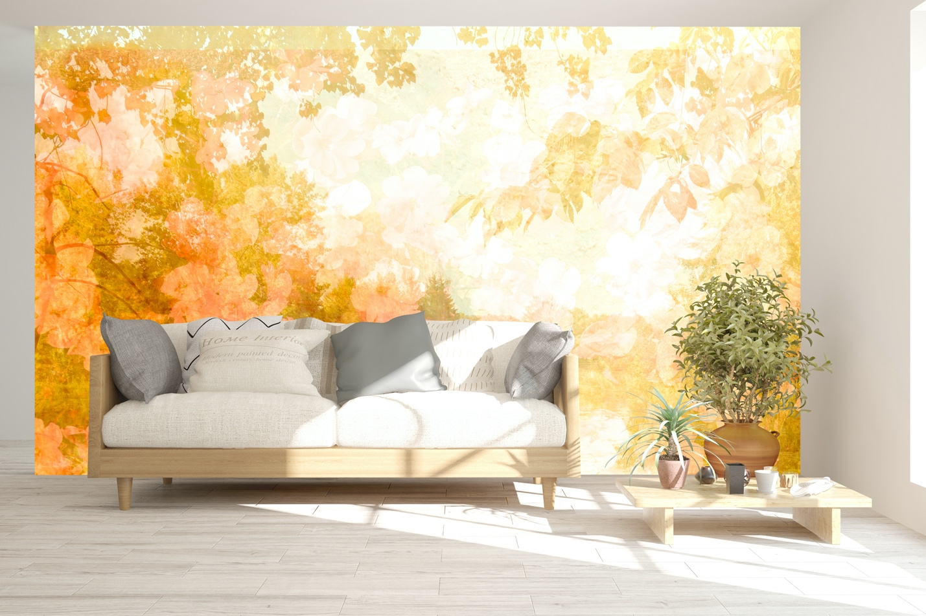

Romantic Garden Mural brings memories of romance and beauty of the natural world.

“Every flower is a soul blossoming in nature.” – Gérard de Nerval (French writer, poet, and translator Gérard Labrunie, a major figure of French romanticism…)

Canadian artist Marlene Luce’s inspiration comes from a mixture of images from the natural world while traveling.
This collection is custom printed on non-woven mat stucco effect wallpaper suitable for residential and commercial projects.
Marlene Luce is represented by Christopher Kohler m: +1-917-719-1836
at info@marleneluce.com
Made with love in Montreal, Canada.

